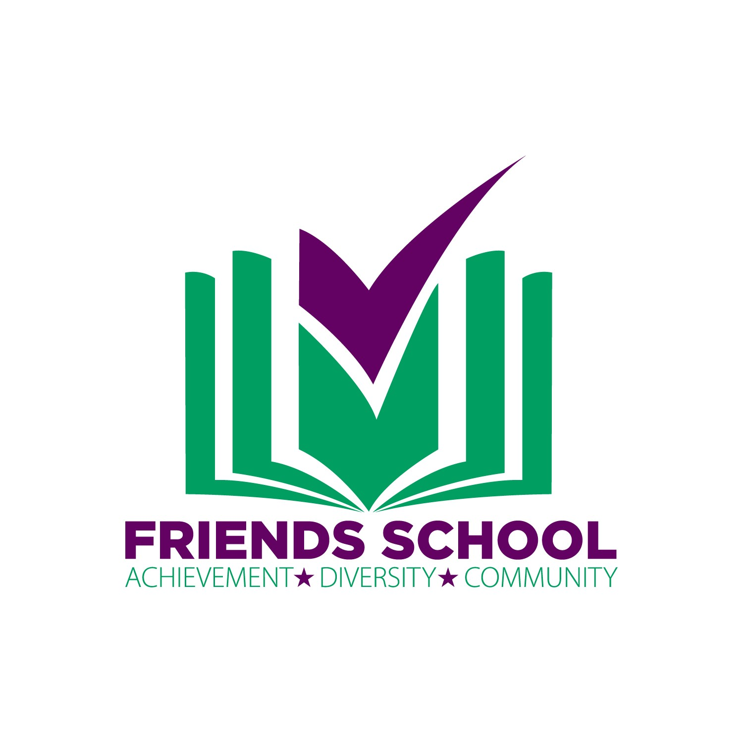
2018 Auction Sponsorship Opportunities

Sponsors will receive excellent exposure and benefits through our event branding and media placements. All benefits can be customized to meet the needs of the sponsor.

Benefactor $3,500
- Logo placement on a selection print & digital materials related to the event (auction program, FSL Facebook page, event flyers)
- Logo placement on sponsor banner located in lobby of Palace Theater, bar signage, cocktail/bistro table tents
- Logo placement on Friends School Website
- Logo placement on 1/2-page advertisement on the interior of gala program
- Honorable Mention at Gala
- 5 tickets to event

Contributor $2,500
- Logo placement on event signage (bar signage, table tents)
- Logo placement on FSL website
- 3/4-page advertisement in auction program
- 5 tickets to event

Stewardship $1,500
- Logo placement on event signage (table tents)
- FSL website acknowledgement
- 3/4-page advertisement in auction program
- 4 tickets to event

Thank you for your consideration!

