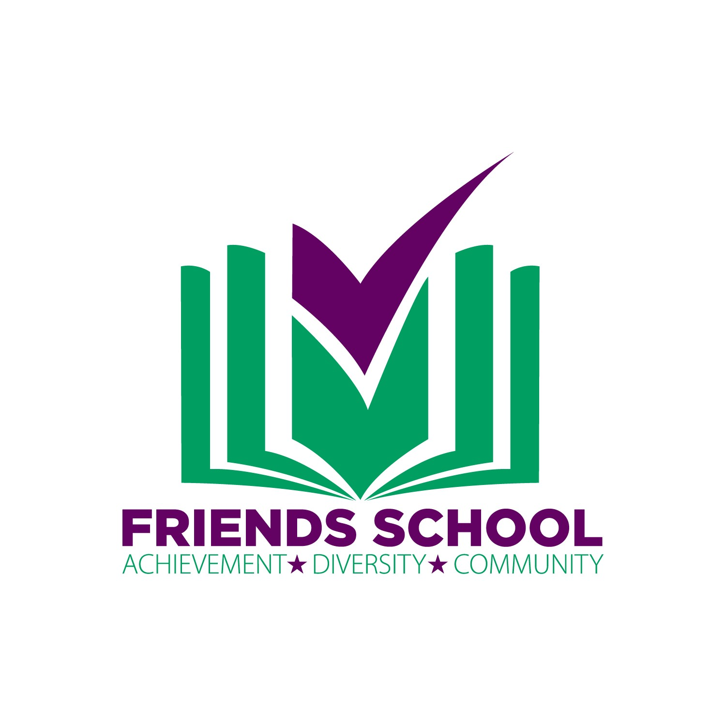

Eat, Drink, and Be Tacky!
Friends School 2019 Auction/Gala Sponsorship Proposal

Friends School invites you to become the Presenting Sponsor for the 2019 Friends School gala and auction Eat, Drink, and Be Tacky!

Presenting Sponsorship: $30,000-$40,000- As the Presenting Sponsor, you will receive optimal sponsorship recognition. The Presenting Sponsor will receive excellent exposure and benefits through branding and media placement. All benefits are negotiable and can be customized to fit the needs of the sponsor.

A sponsorship of $20,000 to $40,000 will receive the following recognition and benefits for the period of one year.

- Sponsor name will be part of the official event name (i.e.: Sponsor Name presents Eat, Drink, and Be Tacky!: Friends School 2019 Gala)
- Co-branding with name & logo placement on all print & digital materials related to the event (invitations, programs, save the date cards, rsvp cards, Facebook, website)
- Recognition on television and radio media (if applicable to event)
- Name placement through all signage at the event.
- Logo placement on Step & Repeat banners, which serve as backdrop for all press releases related to event (if applicable to event)
- Name & logo recognition on all press releases related to event
- Logo placement on Friends School Website
- Logo placement on front of gala program and full page ad on the interior of gala program
- Special Recognition during gala with speaking opportunity
- Unlimited tickets to event

Eat, Drink, and Be Tacky!
Friends School 2019 Gala Sponsorship Proposal

Friends School invites you to become the Title Sponsor for the 2019 Friends School gala and auction Eat, Drink, and Be Tacky!

Presenting Sponsorship: $20,000-$30,000- As the Title Sponsor, you will receive premium sponsorship recognition. The Title Sponsor will receive excellent exposure and benefits through branding and media placement. All benefits are negotiable and can be customized to fit the needs of the sponsor.

A sponsorship of $20,000 to $40,000 will receive the following recognition and benefits for the period of one year.

- Sponsor name will be part of the official event name (i.e.: Sponsor Name presents Eat, Drink, and Be Tacky! : Friends School 2019 Gala)
- Prominent name & logo placement on all print & digital materials related to the event (invitations, programs, save the date cards, rsvp cards, Facebook, website)
- Name placement through all signage at the event.
- Logo placement on Step & Repeat banners, which serve as backdrop for all press releases related to event (if applicable to event)
- Name & logo recognition on all press releases related to event
- Logo placement on Friends School Website
- Logo placement on front of gala program, 1/2-page ad on the interior of gala program
- Special Recognition during gala
- 10 tickets to event

Eat, Drink, and Be Tacky!
Friends School 2019 Gala Sponsorship Proposal

Friends School invites you to become the Presenting Sponsor for the 2019 Friends School gala and auction Eat, Drink, and Be Tacky!

Supporting Sponsorship: $10,000-$20,000- As the Supporting Presenting Sponsor, you will receive preferred sponsorship recognition. The Supporting Sponsor will receive excellent exposure and benefits through branding and media placement. All benefits are negotiable and can be customized to fit the needs of the sponsor.

A sponsorship of $10,000 to $20,000 will receive the following recognition and benefits for the period of one year.

- Name & logo placement on select print & digital materials related to the event (invitations, programs, save the date cards, rsvp cards, Facebook, website)
- Name placement through all signage at the event.
- Name & logo recognition on all press releases related to event
- Logo placement on Friends School Website
- 1/2-page ad on the interior of gala program
- Honorable Mention during gala
- 10 tickets to event

Eat, Drink, and Be Tacky!
Friends School 2019 Gala Sponsorship Proposal

Friends School invites you to become the Presenting Sponsor for the 2019 Friends School gala and auction Eat, Drink, and Be Tacky!

Major Sponsorship: $10,000- As the Major Sponsor, you will receive special sponsorship recognition. The Major Sponsor will receive excellent exposure and benefits through branding and media placement. All benefits are negotiable and can be customized to fit the needs of the sponsor.

A sponsorship of $10,000 will receive the following recognition and benefits for the period of one year.

- logo placement on limited print & digital materials related to the event (invitations, programs, save the date cards, rsvp cards, Facebook, website)
- Name placement through all signage at the event.
- Name & logo recognition on select press releases related to event
- Logo placement on Friends School Website
- Logo placement on 3/4-page ad on the interior of gala program
- Mention during gala with speaking opportunity
- 5 tickets to event

